|  |  |  |  |  |
| --- | --- | --- | --- | --- |
|  |  | | |  |
|  |  | | |  |
|  | EM Registers  <<Feature>>  (F003951) | | |  |
|  |  | | |  |
| Document Type | **Feature Document (FD)** | | |  |
| Template Version | **6.1b** | | |  |
| SysML Report Template Version | **O Beta (4/19/2021)** | | |  |
| Document ID | **ffst01.10_featuredocument_sysmlreporttemplate** | | |  |
| Document Location |  | | |  |
| Document Owner | **Smith, George (G.) <gsmit560@ford.com>** | | |  |
| Document Revision | **FD0** | | |  |
| Document Status | **Draft** | | |  |
| Date Issued | **2021/06/07** | | |  |
| Date Revised | **2021/06/07** | | |  |
| Document Classification | GIS1 Item Number: | **27.60/35** | |  |
| GIS2 Classification: | **Confidential** | |
|  | | | | |
|  | | | | |
| Document Approval | | | | |
| Person | Role | | Email Confirmation | Date |
|  |  | |  |  |
|  |  | |  |  |

**Auto-Generated by MagicDraw**

Printed Copies Are Uncontrolled

# Disclaimer

**This document contains Ford Motor Company Confidential information. Disclosure of the information contained in any portion of this document is not permitted without the expressed, written consent of a duly authorized representative of Ford Motor Company, Dearborn, Michigan, U.S.A.**

**Copyright, Ó 2021 Ford Motor Company**

This document contains information developed and accumulated by and for FORD MOTOR COMPANY. As such, it is a proprietary document, which, if disseminated to unauthorized persons, would provide others with restricted information, data, or procedures not otherwise available, exposing the FORD MOTOR COMPANY to potential harm.

Employees and suppliers having custody of this specification or authorized to use it must be cognizant of its proprietary nature and ensure that the information herein is not made available to unauthorized persons.

FORD MOTOR COMPANY reserves the right to protect this work as an unpublished copyrighted work in the event of an inadvertent or deliberate unauthorized publication. FORD MOTOR COMPANY also reserves its rights under copyright laws to protect this work as a published work.

This document or portions thereof shall not be distributed outside FORD MOTOR COMPANY without prior written consent. Refer all questions concerning disclosure to the author(s) or to any duly authorized representative of Ford Motor Company.

# Contents

1.1.2 Decomposition of Functional Safety Requirement 13

Disclaimer 22

Contents 23

2 Introduction 26

2.1 Document Purpose 26

2.2 Document Scope 26

2.3 Document Audience 26

2.3.1 Stakeholder List 26

2.4 Document Organization 26

2.4.1 Document Context 26

2.4.2 Document Structure 27

2.5 Document Conventions 27

2.5.1 Requirements Templates 27

3 Feature Overview 28

3.1 Purpose and Description of Feature 28

3.2 Feature Variants 28

3.2.1 Regions & Markets 29

3.3 Input Requirements 29

3.3.1 Legal Requirements 30

3.3.2 Trustmark Requirements 30

3.3.3 Industry Standards 30

3.3.4 Attribute Requirements 30

3.4 Lessons Learned 30

3.5 Assumptions 31

3.6 References 31

3.6.1 Ford Documents 32

3.6.2 External Documents and Publications 32

3.7 Glossary 33

3.7.1 Parameters / Values 33

4 Feature Context 34

4.1 Feature Context Diagram 34

4.2 List of Influences 34

5 Feature Modeling 36

5.1 Operation Modes and States 36

5.2 Use Cases 38

5.2.1 Use Case Diagram 38

5.2.2 Actors 39

5.2.3 Use Case Descriptions 39

5.3 Driving and Operation Scenarios 43

5.4 Decision Tables 45

6 Feature Requirements 46

6.1 Functional Requirements 46

6.1.1 Error Handling 47

6.2 Non-Functional Requirements 47

6.2.1 Safety 47

6.2.2 Security 47

6.2.3 Reliability 47

6.3 HMI Requirements 47

6.4 Other Requirements 48

6.4.1 Design Requirements 48

6.4.2 Manufacturing Requirements 48

6.4.3 Service Requirements 48

6.4.4 After Sales Requirements 48

6.4.5 Process Requirements 48

6.4.6 Uncategorized Requirements 49

7 Functional Safety 50

7.1 System Behaviors for HARA 50

7.2 Safety Assumptions 50

7.3 Safety Goals 51

7.4 Functional Safety Requirements 53

7.4.1 Safety Goal: 53

7.4.2 Derivation of Functional Safety Requirements on Assumptions 55

7.5 ASIL Decomposition of Functional Safety Requirements 56

8 Architecture 57

8.1 Functional Architecture 57

8.1.1 List of Functions 57

8.2 Logical Architecture 58

8.2.1 Logical Interfaces 59

9 Open Concerns 61

10 Revision History 62

11 Appendix 63

11.1 Definitions 63

11.2 Abbreviations 63

**List of Figures**

Figure 1. 12

Figure 2: 28

Figure 3: - 28

Figure 4: 34

Figure 5: 36

Figure 6: 38

Figure 7:  55

Figure 8: 57

Figure 9: 58

**List of Tables**

Table 1: Features described in this FD 26

Table 2: Feature Variants 29

Table 3: Regions & Markets 29

Table 4: Ford internal Documents 32

Table 5: Ford internal Documents *(not specified in SysML model)* 32

Table 6: External documents and publications 32

Table 7: External documents and publications *(not specified in SysML model)* 33

Table 8: Parameters / Values used in this document *(Not supported by MagicDraw report generation)* 33

Table 9: List of Influences 35

Table 10: Operation Modes and States on 36

Table 11: Transitions between Operation Modes and States on 38

Table 12: List of Actors 39

Table 13: System Behaviors for HARA 50

Table 14: Functional Safety Assumptions 51

Table 15: Functional Safety Goals 53

Table 16: List of Functions 58

Table 17: List of Functions on 58

Table 18: Feature Interactions 59

Table 19: Feature Interactions on 59

Table 20: Open Concerns *(Not supported by MagicDraw report generation)* 61

Table 21: Definitions used in this document 63

Table 22: Abbreviations used in this document 64

# Introduction

## Document Purpose

A Feature Document (FD) document defines a Feature on [Concept Level](https://bd101001.pd2.ford.com/stages/#/workspace/209/_vv/(process/activity/_Y6ftAPI2VsW5zd82DgHb6g)). It specifies **what** the feature shall do and how it shall behave from customer perspective. It should also provide reasoning and background **why** we have the feature in the vehicle.

The FD also serves as an Item Definition as defined by ISO26262 for those features, which follow the Ford Functional Safety process. Refer [FFSG01.10 Feature Document Guideline](https://azureford.sharepoint.com/sites/GlobalFunctionalSafety/Released%20Templates%20Guidelines%20and%20Examples/Guidelines/FFSG01.10_FeatureDocument_Guideline.pdf) for how to apply the Feature Doc template for Functional Safety.

## Document Scope

This Feature Document (FD) specifies the following features:

|  |  |  |  |
| --- | --- | --- | --- |
| **Feature ID** | **Feature Name** | **Owner** | **Reference** |
| F003951 | EM Registers  (Program(s): CDX746/747 24MY) | Smith, George (G.) <gsmit560@ford.com> |  |

Table 1: Features described in this FD

## Document Audience

The FD is written by the feature owner of Smith, George (G.) <gsmit560@ford.com>. All Stakeholders, i.e., all people who have a valid interest in the feature should read and, if possible, review the FD. It needs to be guaranteed, that all stakeholders have access to the currently valid version of the FD.

### Stakeholder List

For the latest list of stakeholder of the feature and their influence refer to <Put VSEM Link here>.

|  |  |  |  |  |
| --- | --- | --- | --- | --- |
| **Name** | **CDSID** | **Contact Info** | **Role** | **Stakeholder Group** |
| Vikaram Gokhale | vgokhale |  | Feature Delivery Supervisor |  |
| Landie Berry | cberry37 |  | HMI UX |  |
| William Johnston | wjohnst2 |  | Supervisor Occupant Features |  |
| Robert Paquette | rpaquet2 |  | Infotainment Systems Engr |  |
| Dinh Tran | dtran39 |  | Infotainment Systems Engr |  |
| Jason Richardson | jricha41 |  | Climate Core Engr | VESC |
| Michelle Churchill | mchurc35 |  | D & R Engineer |  |
| Andrew Zourob | azourob |  | Climate Control Core Engr | VESC |
| Ken Cunningham | kcunni16 |  | FuSa Coach |  |
| George Smith | GSMIT560 |  | Feature Owner | Interior Cockpit and Trim Core Engineerint |
| Steven Jacobson | sjcobse |  | Feature Champion |  |
| Christopher Van Auken | cvanauke |  | RCCM Engineer | VESC |
| Andres Portillo Reyes | aportil9 |  | Climate Hardware Engr | VESC |
| Aamir Pasha | apasha |  | Feature Delivery Engineer |  |
| Martin Lindell | mlindel4 |  | Climate CFD |  |
| Mitali Chakrabarti | mchakrab |  | Climate Features Supervisor |  |
| Neelima Majjiga | nmajjiga |  | Infotainment Systems Engr |  |
| Julee Harlow | jharlow6 |  | HMI Supervisor |  |
| Jamie Liao | jliao |  | Climate Hardware Engr | VESC |
| Andrew Zourob | azourob |  | Climate Control Core Engr |  |
| Laura Check | LBUREK |  | SYNC3 Supervisor |  |
| Jorge Aaujo | jarauj59 |  | Register Engineer |  |
| Joe Qussar | jqussar |  | FuSa Engr |  |
| Demetrius Johnson-Gault | djohn840 |  | HMI Core Engr |  |
| Joshua Cerda | jcerda7 |  | Modeling Team Member |  |
| Greg Kopp | gkopp6 |  | HMI Engineer |  |
| Martin Imhof | mimhof4 |  | Model Architect |  |
| Tao Zhou | tzhou32 |  | Climate Core Engr | VESC |
| Fernando OVando | joveaneo |  | Register Engineer |  |
| Cindy Rutyna | crutyna |  | Supervisor Climate E/E | VESC |

## Document Organization

### Document Context

Refer to the [Specification Structure page](http://wiki.ford.com/display/RequirementsEngineering/Specification+templates) in the [Ford RE Wiki](http://wiki.ford.com/display/RequirementsEngineering/Requirements+Engineering+for+SW+Enabled+Features) to understand how the FD relates to other Ford Requirements Documents and Specifications.

### Document Structure

The structure of this document is explained below:

**Introduction** – Explains how to use this document including responsibilities and requisite documents. Explains the terminology. Gives a clarification of the definitions, concepts and abbreviations used in the document.

**Feature Overview** – States briefly the background and the purpose of the feature, feature variants and corresponding regions and markets. Also includes input requirements, assumptions and constraints.

**Feature Context** – describes all external entities, which have an influence on the feature.

**Feature Modeling** – Contains Use Case, Driving Scenarios, State Charts to describe the functional behavior of the feature.

**Feature Requirements** – Lists functional and non-functional requirements of the feature.

**Functional Safety** – Lists System Behaviors, Safety Goals and Safety Requirements of the feature.

**Cybersecurity** – Lists Security Goals and Security Requirements of the feature.

**Architecture** – Shows the coarse architecture, which the feature requirements are deployed to. Describes the elements and the boundary of the feature as well as the decomposition and distribution of associated functions.

**Traceability Matrix** – Traceability Matrix.

**Open Concerns** – List of Open Concerns

**Revision History** – Document Change History including a list of new or modified requirements. The requirements in this document are tagged, and this section contains different types of tables listing all, new, or changed requirements by their title and page no.

**Appendix** – Appendix

## Document Conventions

### Classification of Chapters

A chapter is considered mandatory, unless the chapter or its parent chapter(s) are categorized by using the tag:

**#Classification:** Some Condition

If no requirement/other content is known for a mandatory chapter, leave a statement “Not Applicable”

Some chapters have a follow certain rules in context of specific Ford processes, e.g. Functional Safety. This is indicated at the beginning of the corresponding chapter by the tags:

**#Functional Safety:** Some process specific explanation

**#Cybersecurity:** Some process specific explanation

### Requirements Templates

Refer to “[How to use the Specification Templates](http://wiki.ford.com/display/RequirementsEngineering/How+to+use+the+Specification+Templates?src=contextnavpagetreemode)” on how to use the specification templates and the VBA macros to create/edit the requirements in the specifications.

#### **Requirements Attributes**

The templates provided by *Specification_Macros.dotm* define a list of attributes for each requirement. This helps to classify the requirement. The attributes are explained at [RE Wiki - Requirements Attributes](http://wiki.ford.com/display/RequirementsEngineering/Requirements+Attributes?src=contextnavpagetreemode).

## References

### Ford Documents

List here all Ford internal documents, which are directly related to the feature.

| **Reference** | **Title** | **Doc. ID** | **Document Location** | **Revision** |
| --- | --- | --- | --- | --- |
| Ford GIS Standard | Ford GIS Standard |  |  |  |

Table 4: Ford internal Documents

### External Documents and Publications

The list of external documents could include books, reports and online sources.

| **Reference** | **Document / Publication** | **Document Location** |
| --- | --- | --- |
| IEEE Std 1012-2004 IEEE Standard for Software Verification and Validation |  |  |
| ISO/IEC 19500-2:2003 | Information technology -- Open Distributed Processing -- Part 2 |  |
| UML Testing Profile (UTP), v1.2 |  |  |
| Wikipedia |  |  |

Table 6: External documents and publications

## Glossary

See Appendix for Definitions and Abbreviations.

### Definitions

### Abbreviations

### Parameters / Values

| **Name** | **Description** | **Range / Resolution** |
| --- | --- | --- |

Table 8: Parameters / Values used in this document

# Feature Overview

## Purpose and Description of Feature

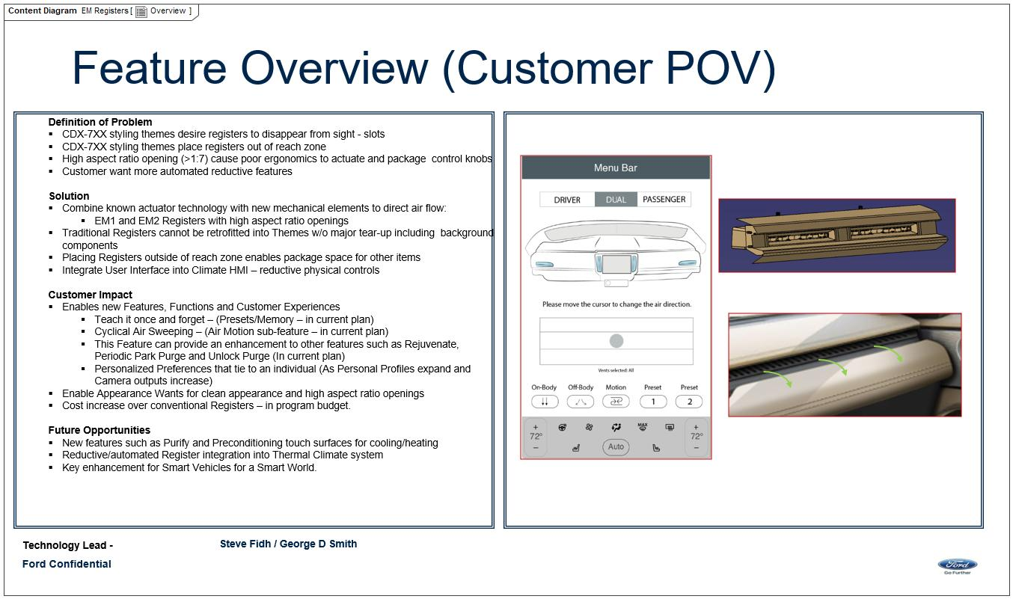

Figure 2: Overview

## Feature Variants

|  |  |  |
| --- | --- | --- |
| **Variant Name** | **Variant Description** | **Remarks** |
| **FNA** | Variant for FNA |  |

Table 2: Feature Variants

### Regions & Markets

|  |  |  |  |  |  |  |
| --- | --- | --- | --- | --- | --- | --- |
| **Market /**  **Region**  Variant Name | **North America** | **South America** | **Europe** | **Middle East/Africa** | **Asia / Pacific** | **China** |
| **FNA** | Mandatory | No | Mandatory | No | No | Mandatory |

Table 3: Regions & Markets

## Input Requirements/Documents

|  |  |  |  |
| --- | --- | --- | --- |
| **Reference**  (Reference as listed in ch. “References”) | **Section/Requirement** | **Description** | **Derived Requirement**  (optional – reference to requirement in ch. “Feature Implementation Requirements”) |
| **Attribute Requirements** | | | |
|  | Personalizable | EM Registers shall be personalizable. (PPP and/or Preset) |  |
|  | HMI Feedback | EM Registers shall give visual feedback to the User through the HMI. |  |
|  | Registers remember users last chosen position Memory | EM Registers shall remember Users last chosen registers directions. |  |
|  | HVAC Vent Air Flow Direction Interface | EM Registers shall control the direction of air exiting the Registers by interfacing with the HMI. |  |
|  | Fast and Accurate | EM Registers shall provide fast and accurate control of the air vents. |  |
|  | Electrically Actuated | EM Registers has electrically actuated and not human actuated air vents. |  |
| **Ford Engineering Standards** | | | |
|  | <Example: some SDS (requirement)> |  |  |
| **Legal Regulations** | | | |
|  | Compliance with FMVSS101 | The Feature shall comply with FMVSS101. |  |
| **Industry Standards** | | | |
|  | ISO 26262 | The system shall be developed according to Ford's implementation of Functional Safety. |  |
| **Other Sources** | | | |
|  | Air Register Life Cycle from IP-0114 | Registers shall withstand at least 7000 cycles. |  |
|  | Air Register Applied Loads from IP-0117 | Register shall withstand loads of 100N and remain functional. |  |

Table 2‑1: Input Requirements/Documents

## Lessons Learned

No lessons learned specified.

## Assumptions

No Assumptions specified.

# Feature Context

## Feature Context Diagram

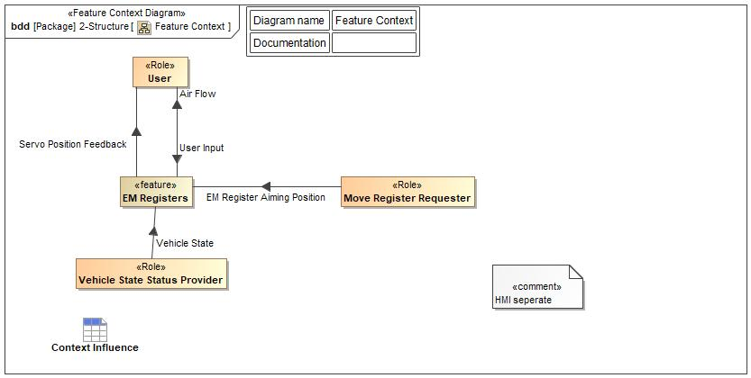

Figure 4: Feature Context

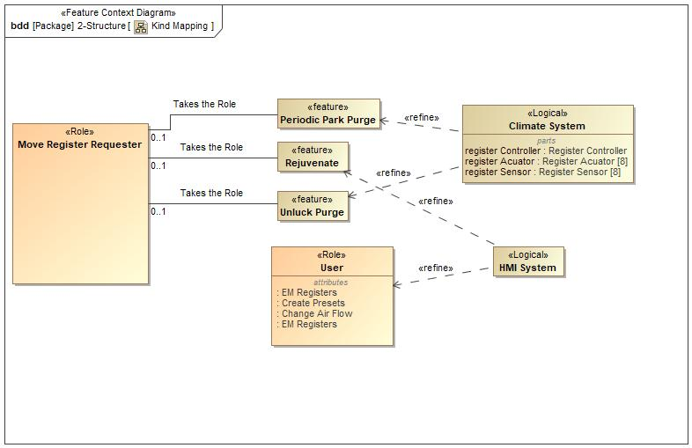

Figure 4: Kind Mapping

## List of Influences

|  |  |  |
| --- | --- | --- |
| **ID** | **External Entity** | **Influence Description** |
| Air Flow | EM Registers To User | Physical air flow to the user/cabin from the feature |
| EM Register Aiming Position | Move Register Requester To EM Registers | Features(such as Rejuvenate) give commands to EM Register Feature on Air Flow, Position, and Movement |
| Servo Position Feedback | EM Registers To User | Feature gives feedback to the User of the servo/louver position and movement |
| User Input | User To EM Registers | User inputs desired position and movement for registers. |
| Vehicle State | Vehicle State Status Provider To EM Registers | Gives the Vehicle state of the vehicle to trigger the start up and shut down attributes of the feature. |

Table 9: List of Influences

# Feature Modeling

## Operation Modes and States

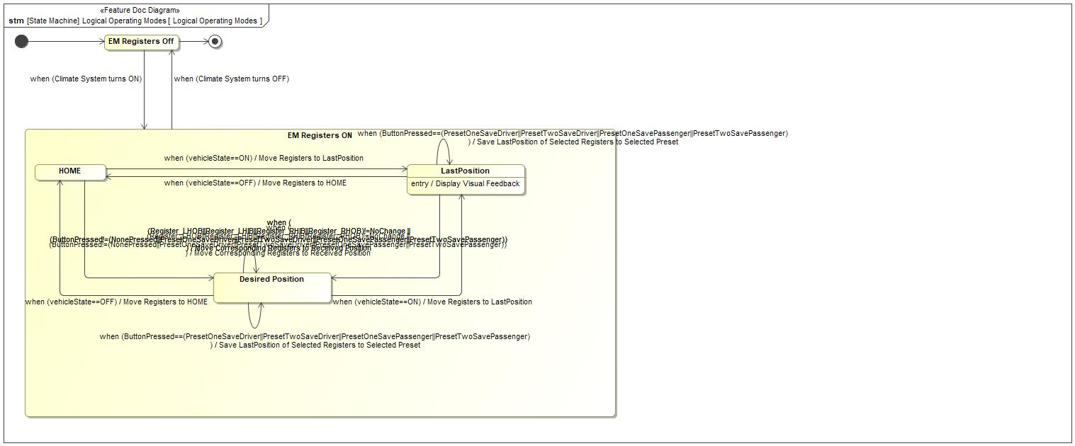

Figure 5: Logical Operating Modes

|  |  |  |
| --- | --- | --- |
| **State** | **Description** | **Requirements Reference** (optional) |
| Desired Position | Registers moved to desired position state |  |
| EM Registers Off | EM Registers Off State |  |
| EM Registers ON | EM Registers on state |  |
| HOME | Register HOME position state when registers move to a standard nominal position |  |
| LastPosition | Entry behavior: Display Visual Feedback |  |

Table 10: Operation Modes and States on Logical Operating Modes

|  |  |  |  |  |
| --- | --- | --- | --- | --- |
| **Transition ID** | **Source** | **Destination** | **Description** | **Requirements Reference**  (optional) |
| T1 | Desired Position | LastPosition | ChangeEvent when (vehicleState==ON) |  |
| T2 | Desired Position | HOME | ChangeEvent when (vehicleState==OFF) |  |
| T3 | HOME | Desired Position | Name: Move Registersto HOME position  Effect: Move Corresponding Registers to Received Position  ChangeEvent when ( (Register_LHOB||Register_LHIB||Register_RHIB||Register_RHOB)!=NoChange || (ButtonPressed!=(NonePressed||PresetOneSaveDriver||PresetTwoSaveDriver||PresetOneSavePassenger||PresetTwoSavePassenger)) ) |  |
| T4 | LastPosition | Desired Position | Effect: Move Corresponding Registers to Received Position  ChangeEvent when ( (Register_LHOB||Register_LHIB||Register_RHIB||Register_RHOB)!=NoChange || (ButtonPressed!=(NonePressed||PresetOneSaveDriver||PresetTwoSaveDriver||PresetOneSavePassenger||PresetTwoSavePassenger)) ) |  |
| T5 | HOME | LastPosition | Effect: Move Registers to LastPosition  ChangeEvent when (vehicleState==ON) |  |
| T6 |  |  |  |  |
| T7 | Desired Position | Desired Position | Name: Move Registers to Desired Position  Effect: Move Corresponding Registers to Received Position  ChangeEvent when ( (Register_LHOB||Register_LHIB||Register_RHIB||Register_RHOB)!=NoChange || (ButtonPressed!=(NonePressed||PresetOneSaveDriver||PresetTwoSaveDriver||PresetOneSavePassenger||PresetTwoSavePassenger)) ) |  |
| T8 | LastPosition | HOME | Effect: Move Registers to HOME  ChangeEvent when (vehicleState==OFF) |  |
| T9 | EM Registers Off | a |  |  |
| T10 | Desired Position | Desired Position | Name: when (ButtonPressed==(PresetOneSaveDriver||PresetTwoSaveDriver||PresetOneSavePassenger||PresetTwoSavePassenger))  / Save LastPosition of Selected Registers to Selected Preset  ChangeEvent when (ButtonPressed==(PresetOneSaveDriver||PresetTwoSaveDriver||PresetOneSavePassenger||PresetTwoSavePassenger) ) |  |
| T11 | LastPosition | LastPosition | Name: when (ButtonPressed==(PresetOneSaveDriver||PresetTwoSaveDriver||PresetOneSavePassenger||PresetTwoSavePassenger))  / Save LastPosition of Selected Registers to Selected Preset  ChangeEvent when (ButtonPressed==(PresetOneSaveDriver||PresetTwoSaveDriver||PresetOneSavePassenger||PresetTwoSavePassenger) ) |  |
| T12 | EM Registers Off | EM Registers ON | ChangeEvent when (Climate System turns ON) |  |
| T13 | EM Registers ON | EM Registers Off | Name: after (30 seconds) && when(vehicleState==OFF)  ChangeEvent when (Climate System turns OFF) |  |

Table 11: Transitions between Operation Modes and States on Logical Operating Modes

## Use Cases

### Use Case Diagram

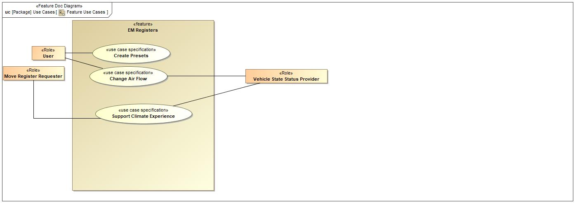

Figure 6: Feature Use Cases

### Actors

| **Actor** | **Description** |
| --- | --- |
| Move Register Requester | This Block is taking the place of every Feature that will be interacting with the EM Registers Feature for the purposes of moving the registers. The Kind Mapping will show what features this block is representing. |
| User | The User is anyone that is inside the vehicle. |
| Vehicle State Status Provider | The EM Registers feature needs to know when the vehicle is turned on(AKA the ignition is turned over). |

Table 12: List of Actors

### Use Case Descriptions

Support Climate Experience

|  |  |  |
| --- | --- | --- |
| **Actors** | Primary | Move Register Requester |
| Secondary | Vehicle State Status Provider |
| **Subject** |  | EM Registers |
| **Description** |  |  |
| **Preconditions** | PreC1 |  |
| **Triggers** | T1 | Move Register Requester accesses feature |
| **Main Flow Description** |  | Another feature receives access |
| **Main Flow** | M1 | Check vehicle on and HMI on status |
| M2 | Receive unsupervised move register request |
| M3 | Move registers to desired position |
| M4 | Provide Feedback to user |
| **Postconditions** | PostC1 | Register positions are not saved to Home position |

Change Air Flow

|  |  |  |
| --- | --- | --- |
| **Actors** | Primary | Move Register Requester |
| Secondary | Vehicle State Status Provider |
| **Subject** |  | EM Registers |
| **Description** |  |  |
| **Preconditions** |  |  |
| **Triggers** | T1 | Move Register Requestor Send Register Move Request From Another Feature |
| T2 | User Request to Adjust Register |
| T3 | User Selects Cycling Option |
| T4 | User Selects Preset |
| T5 | Move Register Requestor Turns Vehicle ON/OFF |
| **Main Flow Description** |  | The Registers are moved as desired. |
| **Main Flow** | M1 | Check vehicle on and HMI on status |
| M2 | Request to adjust register |
| M3 | Input move register request |
| M4 | Provide user feedback |
| **Exceptional Flow Description** |  | EM Registers feature behavior when vehicle is Turned ON/OFF |
| **Exceptional Flow Steps** | E1 | Move Register Requestor Turns Vehicle ON/OFF. |
| E2 | EM Registers Move Registers |
| **Postconditions** | PostC1 | Registers have moved resulting in changed air flow within the cabin. |

Create Presets

|  |  |  |
| --- | --- | --- |
| **Actors** | Primary | User |
| Secondary | Vehicle State Status Provider |
| **Subject** |  | EM Registers |
| **Description** |  |  |
| **Preconditions** | PreC1 | User has selected desired registers to store into preset. |
| **Triggers** | T1 | User Presses and Holds Preset Button |
| **Main Flow Description** |  | A Preset is programed/saved. |
| **Main Flow** | M1 | Check vehicle on and HMI on status |
| M2 | User presses and holds the desired preset button |
| M3 | Store register positions |
| M4 | Provide feedback to user |
| **Postconditions** | PostC1 | Register positions are saved into selected Preset. |

## Driving and Operation Scenarios

## Decision Tables

*Not supported by MagicDraw report generation.*

# Feature Requirements

## Functional Requirements

EM Reg Cyclical Move Command

When Cyclical movement request is received, EM Registers shall request relevant registers to move in the pre-defined cyclical pattern.

|  |  |  |  |  |  |  |  |
| --- | --- | --- | --- | --- | --- | --- | --- |
| Requirement ID: | | | | | | | |
| **Rationale** | Provide user with specific pattern of air flow for a better user experience. | | | | | | |
| **Acceptance Criteria** | Oberservation of air motions. | | | | | | |
| **Notes** |  | | | | | | |
| **Source** | George Smith | | | | | **Owner** | George Smith |
| **Source Req.** | * 2038159061.jpg HVAC Vent Air Flow Direction Interface | | | | | **V&V Method** |  |
| **Type** |  | | | **Priority** |  | **Status** | Ready for Review |
| [Req. Template](http://wiki.ford.com/display/RequirementsEngineering/Requirements+Attributes) Version | | 6.0 | End of Requirement | | | | |

EM Reg Preset Aim Memo

The EM Register feature shall provide the capability of memorizing preset positions when chosen.

|  |  |  |  |  |  |  |  |
| --- | --- | --- | --- | --- | --- | --- | --- |
| Requirement ID: | | | | | | | |
| **Rationale** | Provide a better user experience by memorizing user settings. | | | | | | |
| **Acceptance Criteria** | Oberservation that settings were memorized | | | | | | |
| **Notes** |  | | | | | | |
| **Source** | George Smith | | | | | **Owner** | George Smith |
| **Source Req.** | * 2038159061.jpg Personalizable | | | | | **V&V Method** |  |
| **Type** |  | | | **Priority** |  | **Status** | Ready for Review |
| [Req. Template](http://wiki.ford.com/display/RequirementsEngineering/Requirements+Attributes) Version | | 6.0 | End of Requirement | | | | |

EM Reg Move Command

When position request is received, EM Registers shall command registers to move to the desired position.

|  |  |  |  |  |  |  |  |
| --- | --- | --- | --- | --- | --- | --- | --- |
| Requirement ID: | | | | | | | |
| **Rationale** | Moves the Registers | | | | | | |
| **Acceptance Criteria** | Observation of air flow from registers. | | | | | | |
| **Notes** |  | | | | | | |
| **Source** | George Smith | | | | | **Owner** | George Smith |
| **Source Req.** | * 2038159061.jpg HVAC Vent Air Flow Direction Interface | | | | | **V&V Method** |  |
| **Type** |  | | | **Priority** |  | **Status** | Ready for Review |
| [Req. Template](http://wiki.ford.com/display/RequirementsEngineering/Requirements+Attributes) Version | | 6.0 | End of Requirement | | | | |

EM Reg Memo Closed Pos

EM Registers shall automatically memorize the old Register position each time the Louvers change to the closed position.

|  |  |  |  |  |  |  |  |
| --- | --- | --- | --- | --- | --- | --- | --- |
| Requirement ID: | | | | | | | |
| **Rationale** | Allows the sytem to return the Registers to the last Aim Targets | | | | | | |
| **Acceptance Criteria** | Obseravation that Registrs moved to previous location. | | | | | | |
| **Notes** |  | | | | | | |
| **Source** | George Smith | | | | | **Owner** | George Smith |
| **Source Req.** | * 2038159061.jpg Registers remember users last chosen position Memory | | | | | **V&V Method** |  |
| **Type** |  | | | **Priority** |  | **Status** | Ready for Review |
| [Req. Template](http://wiki.ford.com/display/RequirementsEngineering/Requirements+Attributes) Version | | 6.0 | End of Requirement | | | | |

EM Reg Memo Postion

EM Registers shall automatically memorize the new Register position each time the Louvers change position greater than Threshold.

|  |  |  |  |  |  |  |  |
| --- | --- | --- | --- | --- | --- | --- | --- |
| Requirement ID: | | | | | | | |
| **Rationale** | Allows the sytem to return the Registers to the last Aim Targets | | | | | | |
| **Acceptance Criteria** | Obseravation that Registrs moved to previous location. | | | | | | |
| **Notes** |  | | | | | | |
| **Source** | George Smith | | | | | **Owner** | George Smith |
| **Source Req.** | * 2038159061.jpg Registers remember users last chosen position Memory | | | | | **V&V Method** |  |
| **Type** |  | | | **Priority** |  | **Status** | Ready for Review |
| [Req. Template](http://wiki.ford.com/display/RequirementsEngineering/Requirements+Attributes) Version | | 6.0 | End of Requirement | | | | |

EM Reg Home Position

EM Registers shall move the registers to the HOME position when the vehicle is turned OFF.

|  |  |  |  |  |  |  |  |
| --- | --- | --- | --- | --- | --- | --- | --- |
| Requirement ID: | | | | | | | |
| **Rationale** | Provide the user with continuity between vehicle on/off cycles. | | | | | | |
| **Acceptance Criteria** | Obervation that the EM Registers are the same after a vehicle on/off cycle. | | | | | | |
| **Notes** |  | | | | | | |
| **Source** | George Smith | | | | | **Owner** | George Smith |
| **Source Req.** | * 2038159061.jpg HVAC Vent Air Flow Direction Interface | | | | | **V&V Method** |  |
| **Type** |  | | | **Priority** |  | **Status** | Ready for Review |
| [Req. Template](http://wiki.ford.com/display/RequirementsEngineering/Requirements+Attributes) Version | | 6.0 | End of Requirement | | | | |

EM Reg Preset Command

EM Registers shall move registers to Preset memorized locations when selected by User through HMI.

|  |  |  |  |  |  |  |  |
| --- | --- | --- | --- | --- | --- | --- | --- |
| Requirement ID: | | | | | | | |
| **Rationale** | Provide user with easy preset buttons. | | | | | | |
| **Acceptance Criteria** | Observation of air flow from registers. | | | | | | |
| **Notes** |  | | | | | | |
| **Source** | George Smith | | | | | **Owner** | George Smith |
| **Source Req.** | * 2038159061.jpg Personalizable * 2038159061.jpg HVAC Vent Air Flow Direction Interface | | | | | **V&V Method** |  |
| **Type** |  | | | **Priority** |  | **Status** | Ready for Review |
| [Req. Template](http://wiki.ford.com/display/RequirementsEngineering/Requirements+Attributes) Version | | 6.0 | End of Requirement | | | | |

EM Reg Vehicle ON

The EM Register feature shall move the registers to the LastPosition position when the ignition is turned ON.

|  |  |  |  |  |  |  |  |
| --- | --- | --- | --- | --- | --- | --- | --- |
| Requirement ID: | | | | | | | |
| **Rationale** | Provide the user with continuity between vehicle on/off cycles. | | | | | | |
| **Acceptance Criteria** | Obervation that the EM Registers are the same after a vehicle on/off cycle. | | | | | | |
| **Notes** |  | | | | | | |
| **Source** | George Smith | | | | | **Owner** | George Smith |
| **Source Req.** | * 2038159061.jpg Registers remember users last chosen position Memory * 2038159061.jpg HVAC Vent Air Flow Direction Interface | | | | | **V&V Method** |  |
| **Type** |  | | | **Priority** |  | **Status** | Ready for Review |
| [Req. Template](http://wiki.ford.com/display/RequirementsEngineering/Requirements+Attributes) Version | | 6.0 | End of Requirement | | | | |

### Error Handling

No Error Handling Requirements specified.

## Non-Functional Requirements

### Security

No Security Requirements specified.

### Reliability

No Reliability Requirements specified.

### Performance

Response Time

Registers shall have a response time of < 150ms.

|  |  |  |  |  |  |  |  |
| --- | --- | --- | --- | --- | --- | --- | --- |
| Requirement ID: | | | | | | | |
| **Rationale** | Provides a fast user experience. | | | | | | |
| **Acceptance Criteria** | Testing to oconfirm response time is < 150ms. | | | | | | |
| **Notes** |  | | | | | | |
| **Source** | George Smith | | | | | **Owner** | George Smith |
| **Source Req.** | * 2038159061.jpg Fast and Accurate | | | | | **V&V Method** |  |
| **Type** |  | | | **Priority** |  | **Status** | Ready for Review |
| [Req. Template](http://wiki.ford.com/display/RequirementsEngineering/Requirements+Attributes) Version | | 6.0 | End of Requirement | | | | |

EM Reg After Calibration

EM Register feature shall move Registers to LastPosition after Calibration.

|  |  |  |  |  |  |  |  |
| --- | --- | --- | --- | --- | --- | --- | --- |
| Requirement ID: | | | | | | | |
| **Rationale** | Provides better User Experience | | | | | | |
| **Acceptance Criteria** | Oberservance | | | | | | |
| **Notes** | Non Functional Requirement | | | | | | |
| **Source** | George Smith | | | | | **Owner** | George Smith |
| **Source Req.** | * 2038159061.jpg Registers remember users last chosen position Memory | | | | | **V&V Method** |  |
| **Type** |  | | | **Priority** |  | **Status** | Ready for Review |
| [Req. Template](http://wiki.ford.com/display/RequirementsEngineering/Requirements+Attributes) Version | | 6.0 | End of Requirement | | | | |

EM Reg Calibration

EM Registers shall calibrate the Registers after every stop/start Ignition Interval.

|  |  |  |  |  |  |  |  |
| --- | --- | --- | --- | --- | --- | --- | --- |
| Requirement ID: | | | | | | | |
| **Rationale** | Provide user with consistant lifelong accuracy of airflow direction. | | | | | | |
| **Acceptance Criteria** |  | | | | | | |
| **Notes** | Non Functional Requirement | | | | | | |
| **Source** | George Smith | | | | | **Owner** | George Smith |
| **Source Req.** | * 2038159061.jpg Fast and Accurate | | | | | **V&V Method** |  |
| **Type** |  | | | **Priority** |  | **Status** | Ready for Review |
| [Req. Template](http://wiki.ford.com/display/RequirementsEngineering/Requirements+Attributes) Version | | 6.0 | End of Requirement | | | | |

EM Reg Position Location

EM Registers shall provide control accuracy of EM Register with position error less than MaxPositionError.

|  |  |  |  |  |  |  |  |
| --- | --- | --- | --- | --- | --- | --- | --- |
| Requirement ID: | | | | | | | |
| **Rationale** | Provides accurate control of Air Flow. | | | | | | |
| **Acceptance Criteria** | Observation that visual feedback matches air flow direction. | | | | | | |
| **Notes** |  | | | | | | |
| **Source** | George Smith | | | | | **Owner** | George Smith |
| **Source Req.** | * 2038159061.jpg Fast and Accurate | | | | | **V&V Method** |  |
| **Type** |  | | | **Priority** |  | **Status** | Ready for Review |
| [Req. Template](http://wiki.ford.com/display/RequirementsEngineering/Requirements+Attributes) Version | | 6.0 | End of Requirement | | | | |

Degrees per second

Registers shall move an average speed of 90 degrees per second within +/- 10 degrees per second.

|  |  |  |  |  |  |  |  |
| --- | --- | --- | --- | --- | --- | --- | --- |
| Requirement ID: | | | | | | | |
| **Rationale** | Provide consistent speed | | | | | | |
| **Acceptance Criteria** | Oberservance of consistent speed | | | | | | |
| **Notes** |  | | | | | | |
| **Source** | George Smith | | | | | **Owner** | George Smith |
| **Source Req.** | * 2038159061.jpg Fast and Accurate | | | | | **V&V Method** |  |
| **Type** |  | | | **Priority** |  | **Status** | Ready for Review |
| [Req. Template](http://wiki.ford.com/display/RequirementsEngineering/Requirements+Attributes) Version | | 6.0 | End of Requirement | | | | |

## HMI Requirements

EM Reg HMI Functionality

The EM Register feature shall provide means to control register position and cyclical settings through HMI.

|  |  |  |  |  |  |  |  |
| --- | --- | --- | --- | --- | --- | --- | --- |
| Requirement ID: | | | | | | | |
| **Rationale** | Provide the user with the ability to manually aim registers. | | | | | | |
| **Acceptance Criteria** | Obeservation of air flow. | | | | | | |
| **Notes** |  | | | | | | |
| **Source** | George Smith | | | | | **Owner** | George Smith |
| **Source Req.** | * 2038159061.jpg HVAC Vent Air Flow Direction Interface | | | | | **V&V Method** |  |
| **Type** |  | | | **Priority** |  | **Status** | Ready for Review |
| [Req. Template](http://wiki.ford.com/display/RequirementsEngineering/Requirements+Attributes) Version | | 6.0 | End of Requirement | | | | |

EM Reg HMI Feedback

The EM Register feature shall provide visual feedback of Register Aim directions, Register Air Motion, Register shut off.

|  |  |  |  |  |  |  |  |
| --- | --- | --- | --- | --- | --- | --- | --- |
| Requirement ID: | | | | | | | |
| **Rationale** | Provide the user with visual feedback of the air flow. | | | | | | |
| **Acceptance Criteria** | Obersvation of visual feedback. | | | | | | |
| **Notes** |  | | | | | | |
| **Source** | George Smith | | | | | **Owner** | George Smith |
| **Source Req.** | * 2038159061.jpg HMI Feedback | | | | | **V&V Method** |  |
| **Type** |  | | | **Priority** |  | **Status** | Ready for Review |
| [Req. Template](http://wiki.ford.com/display/RequirementsEngineering/Requirements+Attributes) Version | | 6.0 | End of Requirement | | | | |

## Other Requirements

### Design Requirements

*Not supported by MagicDraw report generation.*

### Manufacturing Requirements

No Manufacturing Requirements specified.

### Service Requirements

No Service Requirements specified.

#### **Cloud Connectivity Data Analytics Requirements**

### After Sales Requirements

No After Sales Requirements specified.

### Process Requirements

No Process Requirements specified.

# Functional Safety

## System Behaviors for HARA

|  |  |  |
| --- | --- | --- |
| **ID** | **Name** | **Description** |
|  | Shut-off Air Flow from one or more vents |  |
|  | Provide Continous Motion of Air Flow in Predetermined Patterns |  |
|  | Aim Air Flow Up/Dn/L/R as requested |  |
|  | Aim Air flow to Predetermined Positions |  |
|  | Memorize Aiming Positon Set by Occupant |  |

Table 13: System Behaviors for HARA

## Functional Safety Assumptions

No Safety Assumptions specified

## Safety Goals

|  |  |  |  |  |
| --- | --- | --- | --- | --- |
| ID | Goal | | | |
|  | **Goal Name** | Prevent Hazard (Example) | | |
| **Description** |  | | |
| **Safety Goal Concept** | Safety Goal Concept:  Warning & Recovery Concept: | | |
| **ASIL** |  | **FTTI** |  |
| **Related FSR IDs** |  | | |

Table 15: Functional Safety Goals

## Functional Safety Requirements

### Safety Goal: Prevent Hazard (Example)

**Name:** Prevent Hazard (Example)

**Purpose:**

**Text:**

**ASIL:**

#### Safety Goal Concept

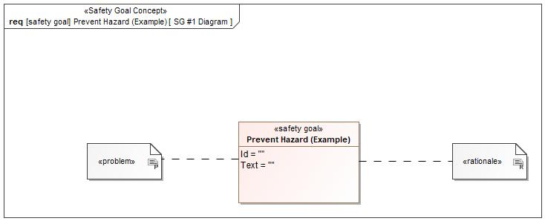

Figure 1: SG #1 Diagram – Prevent Hazard (Example)

*Note: The authoritative source for the Safety Goals is document “FFSD 02 Hazard Analysis* *and Risk Assessment”. The documentation of Safety Goals in this chapter (In the Argumentation for Safety Goal achievement) is for information purposes only.*

*The authoritative source for the Functional Safety Requirements is section 2.1.x.3: of this document. The documentation of Functional Safety Requirements in the following chapter (complete or summarised) is for information purposes only.*

#### Warning and Recovery Concept

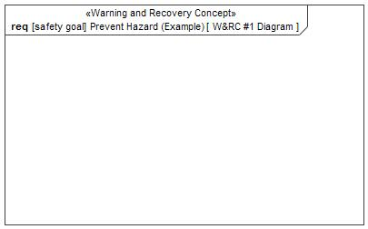

Figure 7: W&RC #1 Diagram – Prevent Hazard (Example)

#### FSRs for - Prevent Hazard (Example)

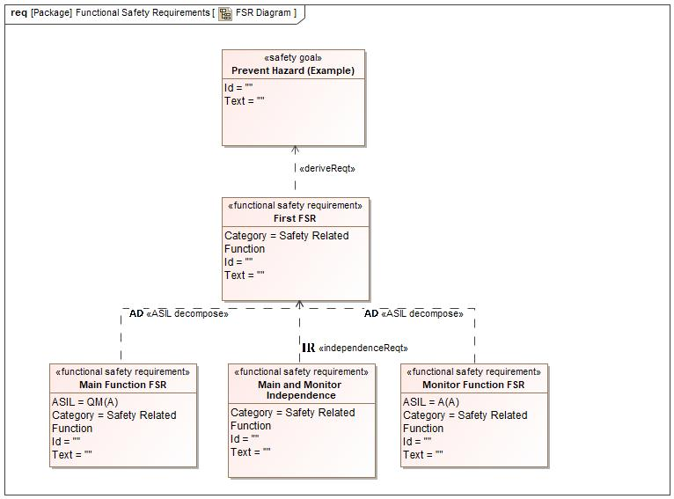

Figure 1. Prevent Hazard (Example)

Monitor Function FSR

Related to:

* Safe States:
  + Safe State #1

|  |  |  |  |  |  |  |  |
| --- | --- | --- | --- | --- | --- | --- | --- |
| Requirement ID: | | | | | | | |
| **Purpose** |  | | | | | | |
| **V&V Acceptance Criteria** |  | | | | | | |
| **Notes** |  | | | | | | |
| **Source** |  | | | | | **Owner** |  |
| **Source Req.** | * 126890827.jpg Prevent Hazard (Example) | | | | | **V&V Method** |  |
| **Type** | N/A | | **Priority** | | N/A | **Status** |  |
| **ASIL** | A(A) | | **Category** | | Safety Related Function | **Fault Handling Time** | N/A |
| [Req. Template](http://wiki.ford.com/display/RequirementsEngineering/Requirements+Attributes) Version | | 6.0 | | End of Requirement | | | |

Main Function FSR

Related to:

* Safe States:
  + Safe State #1

|  |  |  |  |  |  |  |  |
| --- | --- | --- | --- | --- | --- | --- | --- |
| Requirement ID: | | | | | | | |
| **Purpose** |  | | | | | | |
| **V&V Acceptance Criteria** |  | | | | | | |
| **Notes** |  | | | | | | |
| **Source** |  | | | | | **Owner** |  |
| **Source Req.** | * 126890827.jpg Prevent Hazard (Example) | | | | | **V&V Method** |  |
| **Type** | N/A | | **Priority** | | N/A | **Status** |  |
| **ASIL** | QM(A) | | **Category** | | Safety Related Function | **Fault Handling Time** | N/A |
| [Req. Template](http://wiki.ford.com/display/RequirementsEngineering/Requirements+Attributes) Version | | 6.0 | | End of Requirement | | | |

First FSR

Related to:

* Safe States:
  + Safe State #1

|  |  |  |  |  |  |  |  |
| --- | --- | --- | --- | --- | --- | --- | --- |
| Requirement ID: | | | | | | | |
| **Purpose** |  | | | | | | |
| **V&V Acceptance Criteria** |  | | | | | | |
| **Notes** |  | | | | | | |
| **Source** |  | | | | | **Owner** |  |
| **Source Req.** | * 126890827.jpg Prevent Hazard (Example) | | | | | **V&V Method** |  |
| **Type** | N/A | | **Priority** | | N/A | **Status** |  |
| **ASIL** |  | | **Category** | | Safety Related Function | **Fault Handling Time** | N/A |
| [Req. Template](http://wiki.ford.com/display/RequirementsEngineering/Requirements+Attributes) Version | | 6.0 | | End of Requirement | | | |

Main and Monitor Independence

Related to:

* Safe States:
  + Safe State #1

|  |  |  |  |  |  |  |  |
| --- | --- | --- | --- | --- | --- | --- | --- |
| Requirement ID: | | | | | | | |
| **Purpose** |  | | | | | | |
| **V&V Acceptance Criteria** |  | | | | | | |
| **Notes** |  | | | | | | |
| **Source** |  | | | | | **Owner** |  |
| **Source Req.** | * 126890827.jpg Prevent Hazard (Example) | | | | | **V&V Method** |  |
| **Type** | N/A | | **Priority** | | N/A | **Status** |  |
| **ASIL** |  | | **Category** | | Safety Related Function | **Fault Handling Time** | N/A |
| [Req. Template](http://wiki.ford.com/display/RequirementsEngineering/Requirements+Attributes) Version | | 6.0 | | End of Requirement | | | |

### Derivation of Functional Safety Requirements on Assumptions

No Functional Safety Requirements tracing to Assumptions specified.

### ASIL Decomposition of Functional Safety Requirements

### Decomposition of Functional Safety Requirement

| Initial Safety Requirement | First FSR | |
| --- | --- | --- |
| Decomposition Rationale |  | |
| Method for Decomposition | A -> A(A) + QM(A) | |
| Functional Safety Requirement 1 after Decomposition | F-S-Req-ID |  |
| F-S-Req. Title | Monitor Function FSR |
| ASIL | A(A) |
| Rationale |  |
| Satisfied by |  |
| Functional Safety Requirement 2 after Decomposition | F-S-Req-ID |  |
| F-S-Req. Title | QM(A) |
| ASIL | Main Function FSR |
| Rationale |  |
| Satisfied by |  |
| Functional Safety Requirement for Independence | F-S-Req.-ID |  |
| F-S-Req. Title | Main and Monitor Independence |
| ASIL |  |
| Rationale |  |

# CyberSecurity

## Security Goals

|  |  |
| --- | --- |
| ID | Goal |

Table 18: Cybersecurity Goals

## Cybersecurity Requirements

# Architecture

## Functional Decomposition

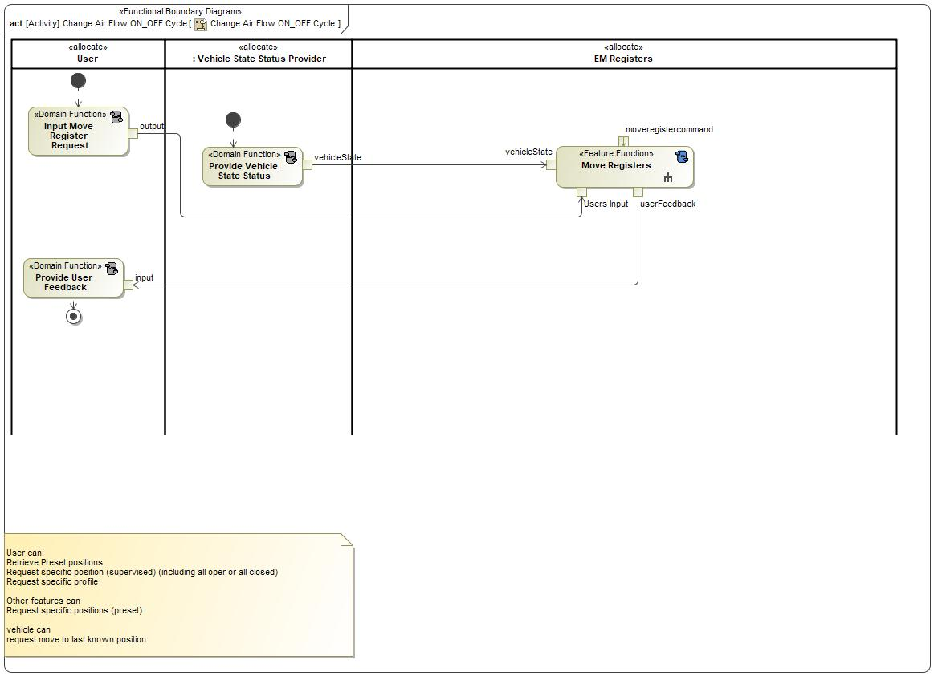

Figure 8: Change Air Flow ON_OFF Cycle

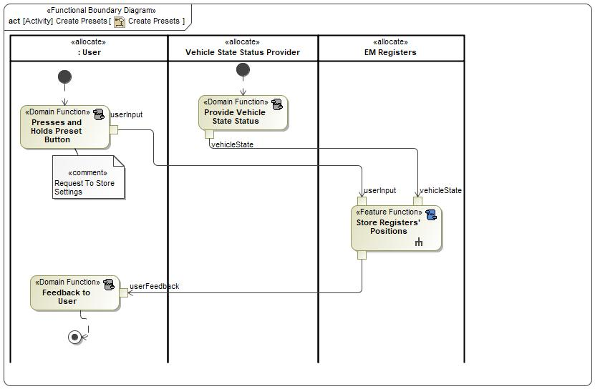

Figure 8: Create Presets

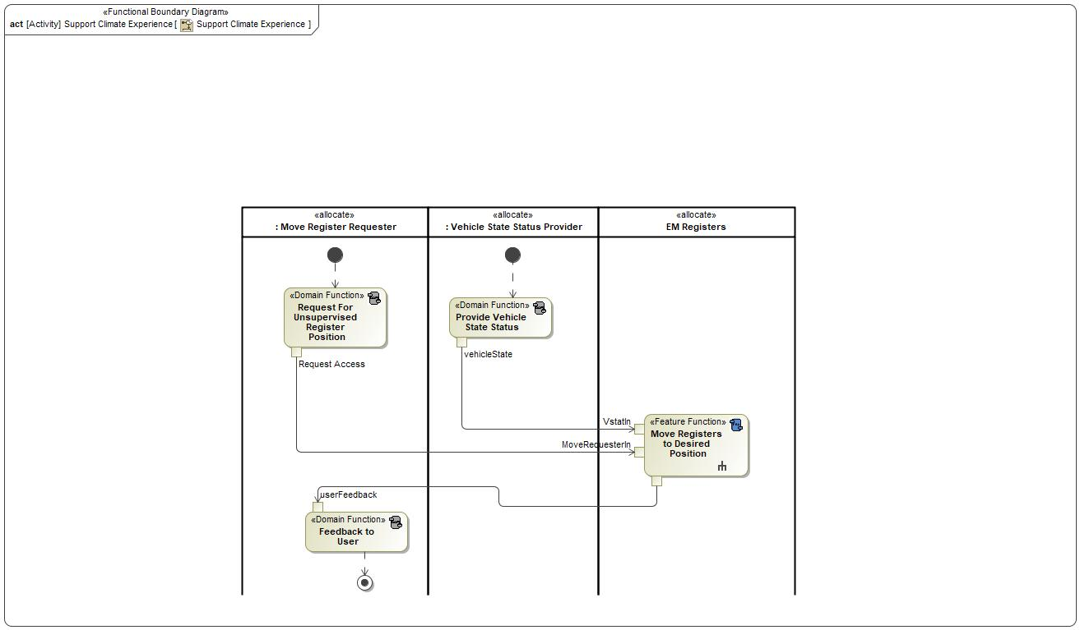

Figure 8: Support Climate Experience

### Functions

| **Function Name** | Description | Comments |
| --- | --- | --- |
| *(activity)* Move Registers | *(activity)* Function to Move Registers to desired location |  |
| *(activity)* Input Move Register Request | *(activity)* Function that allows other features to use EM Registers or User to configure EM Registers |  |
| *(activity)* Provide Vehicle State Status | *(activity)* Function to provide vehicle status to the Move Registers function |  |
| *(activity)* Provide User Feedback | *(activity)* Function to provide user feedback of EM Register requests to HMI Display |  |

Table 17: List of Functions on Change Air Flow ON_OFF Cycle

| **Function Name** | Description | Comments |
| --- | --- | --- |
| *(activity)* Presses and Holds Preset Button | *(activity)* Function to store register position as a preset |  |
| *(activity)* Store Registers' Positions | *(activity)* Feature Function that stores register positions |  |
| *(activity)* Provide Vehicle State Status | *(activity)* Function to provide vehicle status to the Move Registers function |  |
| *(activity)* Feedback to User | *(activity)* Provides Feedback to User via SYNC for EM Register Commands |  |

Table 17: List of Functions on Create Presets

| **Function Name** | Description | Comments |
| --- | --- | --- |
| *(activity)* Feedback to User | *(activity)* Provides Feedback to User via SYNC for EM Register Commands |  |
| *(activity)* Provide Vehicle State Status | *(activity)* Function to provide vehicle status to the Move Registers function |  |
| *(activity)* Move Registers to Desired Position |  |  |
| *(activity)* Request For Unsupervised Register Position | *(activity)* Function that listens for requests for access to feature |  |

Table 17: List of Functions on Support Climate Experience

## Logical Architecture

### Logical Elements

No Logical Elements specified.

### Logical Interfaces

# Traceability Matrix

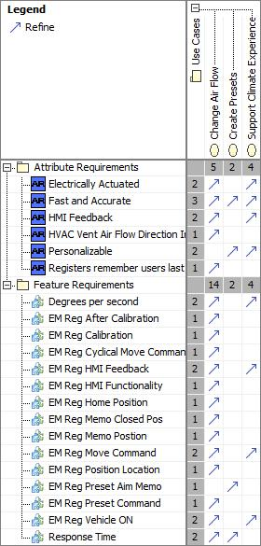

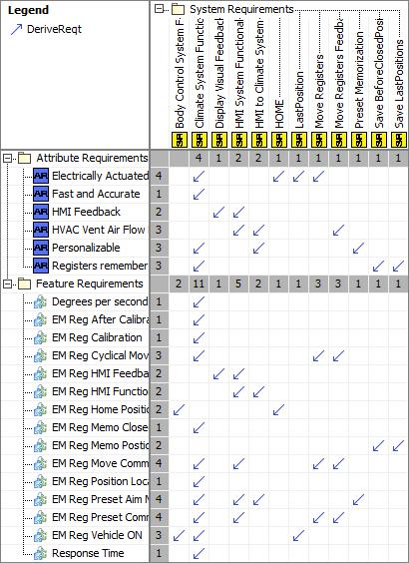

# Open Concerns

| ID | Concern Description | e-Tracker / Reference | Responsible | Status | Solution |
| --- | --- | --- | --- | --- | --- |
| 1 |  |  |  |  |  |

Table 20: Open Concerns *(Not supported by MagicDraw report generation)*

# Revision History

No Revision History found.

## Template Revisions

|  |  |  |  |  |
| --- | --- | --- | --- | --- |
| Version | Rev. | Date | Description | Responsible |
| 0 | 6 | 2015-05-26 | * Chapter “Feature Overview” and made a 2nd level heading. * Chapter “Feature Modeling” divided into 3 subchapter (“Scenarios”, “Use Cases”, “State Machines”) for different modeling methods | Jbaden1 |
| 0 | 7 | 2015-05-27 | * Table of Content updated * Template Revision History chapter added | Jbaden1 |
| 0 | 8 | 2015-07-02 | * Section “Unsettled Issues” added | Alevin7 |
| 0 | 9 | 2015-08-04 | * Section “Feature Variants” added * Section “Feature Boundary Diagram” renamed to “Feature Context Diagram” * Document Properties adapted to match needs of VBA macros | Jbaden1, Awegman1 |
| 1 | 0 | 2015-09-11 | * Section “Feature Variants” reworked * Feature Goals removed. Only “Safety Goals“ chapter remains. * Heading 2 formatting issues corrected. * Requirements / Use Cases Listing removed from traceability chapter. * Formatting of attribute table in Notation chapter corrected * Open Topics / Known Issues chapter moved to the end | Jbaden1 |
| 1 | 1 | 2015-11-16 | * Table-Styles removed (for smooth VSEM import) * Some clean-up of sections “Purpose” and “Audience” | Awegman1, jbaden1 |
| 1 | 2 | 2016-02-26 | * Minor corrections based on lessons learned from CC and PCL pilot (e.g. section market/regions) and discussion with Functional Safety Team (purpose of feature) * Footer corrected * Boundary diagram interface chapter renamed to influences. | Jbaden1 |
| 1 | 3 | 2016-02-26 | * Minor corrections after review with Whitney Keith from Functional Safety team | Jbaden1 |
| 1 | 4 | 2016-03-10 | * Some cleanup of meta-data in Word Properties | Jbaden1 |
| 1 | 5 | 2016-03-10 | * Footer formatting corrected (Issue 19) * Results from review with Functional Safety Team incorporated (Issue 20). | jbaden1 |
| 1 | 6 | 2016-04-18 | * Scenario Template added | Jbaden1 |
| 1 | 7 | 2016-04-18 | * Chapter “Operation Modes and States” moved before “Use Case” section. | Jbaden1 |
| 1 | 8 | 2016-04-18 | * Broken Wiki links repaired. | Jbaden1 |
| 2 | 0 | 2016-05-19 | * Adapted to Specification_Macros.dotm V2.0 * Requirements Templates chapter (ch. 1.7.1) no longer has an attribute table, but refers directly to the Wiki.. | Jbaden1 |
| 2 | 1 | 2016-06-10 | * Table for Context Diagram modified (lists external entities and Influence Description only) | Jbaden1 |
| 2 | 2 | 2016-07-08 | * Template version added to footer * Several hints added to the various sections * Findings from Functional Safety Team incorporated. * RE_SafetyRequirement style added | Jbaden1 |
| 2 | 3 | 2016-09-21 | * Update from Functional Safety Team incorporated (“Lessons Learned”, “System Behaviors for HARA”) | Jbaden1 |
| 2 | 4 | 2016-11-15 | * Update from Functional Safety Team incorporated (“Lessons Learned”, “System Behaviors for HARA”) * Explanatory notes made more formal | Jbaden1 |
| 3 |  |  | Skipped to synchronize with Specification_Macros.dotm |  |
| 4 |  |
| 5 | 0 | 2017-01-13 | * Meta data updated for specification macros, version 3.1 * SW Unit chapter removed for the time being * Green boxes added for user hints | Jbaden1 |
| 5 | 1 | 2017-01-18 | * Minor editorial changes | Jbaden1 |
| 6 | 0 | 2017-02-03 | * CR48: Chapter 6 renamed from “Safety” to “Functional Safety”. New sub-chapter “Safety” introduced in Non-Functional Requirements section | Jbaden1 |
| 6 | 0 | 2017-04-28 | * CR7: “RequirementsTraceability” chapter removed | Jbaden1 |
| 6 | 0 | 2017-11-15 | * CR32/53: New Cover Sheet + Disclaimer replaces FAP-150 like ones. * CR75: Some rewording -> Terminology to Glossary, Notation -> Document Conventions * CR49: Rename “Assumptions & Constraints” to “Assumptions” * CR74: Safety Assumptions added to chapter 6. * CR58: Add function allocation column to Logical Architecture chapter | Jbaden1 |
| 6 | 0 | 2018-01-31 | * CR63: Updated links to Functional Safety Sharepoint | Jbaden1 |
| 6 | 0 | 2018-07-24 | * CR69: Add FSR to FeatureDoc * CR64: Add new section "Design Requirements" to Function Spec and Feature Spec | Jbaden1 |
| 6 | 0 | 2018-08-06 | * CR53: some corrections for metada and formatting | Jbaden1 |
| 6 | 0 | 2018-09-28 | * Broken links to RE Wiki repaired | Jbaden1 |
| 6 | 0 | 2018-10-31 | * Cover sheet and footer more GIS like. Functional Safety team feedback incorporated:   + New subsections “Functional Safety Requirements, (Decomposed) FSRs and Parameters / Values   + Removal of “Logical Architecture” | Jbaden1 |
| 6 | 0 | 2018-12-12 | * FSR template removed, now as a macro in the Specification_Macros.dotm | Jbaden1 |
| 6 | 0a | 2019-05-23 | * Re-introduce “Logical Architecture” (for Functional Safety) | Jbaden1 |
| 6 | 0b | 2019-06-26 | * Chapter “Logical Elements” in “Logical Architecture” section added (FuSa CR 15136240) | Jbaden1 |
| 6 | 0c | 2019-03-22 | * Chapter “Decomposed FSRs” renamed to “ASIL Decomposition of Functional Safety Requirements” and moved beneath Chapter “Functional Safety Requirements”. Explanatory text improved. | Jbaden1 |
| 6 | 0c | 2019-04-05 | * Some wording in ASIL decomposition table modified. Description of fields in that table improved. | Jbaden1 |
| 6 | 0c | 2019-06-24 | * “Input Requirements” section modified (table approach as for the other RE templates). * “References” and “Glossary” chapter moved to the “Introduction” chapter. | Jbaden1 |
| 6 | 0c | 2019-07-02 | * "Important" box added on cover sheet which points to the macros | Jbaden1 |
| 6 | 0c | 2019-07-02 | * Subsection “Error Handling” removed form chapter “Feature Requirements”->”Functional Requirements” (teams are free to create their own substructure of that section). Note tells author not to forget about error handling. * Hint for chapter “Feature Variants” improved reworded upon request from Functional Safety Team. | Jbaden1 |
| 6 | 0c | 2019-05-11 | * Copyright notice shortened and moved to cover sheet and added to footer (to be compliant [with Ford copyright guidelines](http://www.fgti.ford.com/client/NewFGTI/CopyrightNotice.html)) * Term “Disclaimer” no longer used for what is actually only a copyright notice | Jbaden1 |
| 6 | 0c | 2019-22-11 | * Chapter “Input Requirements/Documentst: minor modifications (examples added), Word comment removed” | Jbaden1 |
| 6 | 0c | 2019-12-05 | * Upstream Documents section added to “Input Requirements/Documents” table * Custom style table formatting removed * Hint on system behaviors modified as requested from FuSa team | Jbaden1 |
| 6 | 0c | 2019-12-09 | * Term “Upstream Documents” replaced by “Attribute Requirements” in “Input Requirements/Documents” table * ASIL Decomposition table replaced by a version, which get not corrupted during VSEM import. | Jbaden1 |
| 6 | 0c | 2019-12-10 | * In ch. “Functional Safety Requirements” Word reference Id by Word reference text replaced.. | Jbaden1 |
| 6 | 1a | 2020-02-12 | * New chapter “Cybersecurity” added. | Jbaden1 |
| 6 | 1a | 2020-03-03 | * All User Hints formatted using style “RE_UserHint” to enable automatic removal by a macro. | Jbaden1 |
| 6 | 1a | 2020-03-04 | * Chapter “Cloud Connectivity Data Analytics Requirements” added upon request by D. Crockett/J. Rawlings | Jbaden1 |
| 6 | 1a | 2020-03-09 | * Missing doc property “LatestSigMappingID” and “LatestAisInterfaceID” added * doc property “CopyrightDate” re-formatted to text and copyright date field in footer corrected * Version numbering re-initialized as 0.1 * Init value of version/revision date set to “yyyy/mm/dd” instead of “yyyy-mm-dd” to be in line with the “Edit Document Property” dialog * type of document property for latest IDs changed to number instead of text | Jbaden1 |
| 6 | 1b | 2020-03-17 | * Chapter “Functional Architecture” renamed to “Functional Decomposition” * New MBSE terminology introduced: “Feature Level”, “Function Level” and “Component Level” renamed to “Concept Level”, “Logical Level” and “Technology Level” | Jbaden1 |
| 6 | 1b | 2020-07-03 | * CR31: Chapter “Traceability Matrix” added. | Jbaden1 |
| 6 | 1b | 2020-23-09 | * CR28: Alignment to [*FFSG01.10 Feature Document Guideline*](https://azureford.sharepoint.com/sites/GlobalFunctionalSafety/Released%20Templates%20Guidelines%20and%20Examples/Guidelines/FFSG01.10_FeatureDocument_Guideline.pdf) for how to apply the Feature Doc template for Functional Safety. New section “Classification of Chapters” added. “Active Tilt Control” Example in section “Logical Architecture” updated based on input from HARA training. | Jbaden1 |
| 6 | 1b | 2020-25-11 | * Reference to process definition in Stages added to “How to Use” section on cover sheet. User hints removed from “Document Purpose” chapter. * RE-Wiki links mostly replaced by Stages links, links to Functional Safety Sharepoint updated | Jbaden1 |

# Appendix

## Definitions

| **Definition** | **Description** |
| --- | --- |
| APIM | Auxillary Protocol Interface Module (Sync Gen 4.2) with Cluster |
| BeforeClosedPosition | The last stationary positions that the registers were in before the registers were closed. To be used to return the registers back to their previous position when the registers are requested to open by the User. |
| calibrate | A process that will provide future accurate positioning for the registers. The process entails moving the registers to the end points and recording the feedback from the sensors. This feedback is used to recalibrate the future voltage commands to move the registers. |
| CIS | Controls Interface Specification |
| High speed | Approximately more than 52 mph (83 kph) |
| HOME | Value that denotes the Home position the registers will move to when the car is turned off. |
| LastPosition | Denotes the last stationary position that the registers were in. For example the position before the vehicle was turned OFF, before a Cycling option was selected, or before another feature requested to move the registers. |
| Low speed | Approximately 12 to 36 mph (19 to 58 kph ) |
| MaxPositionError | The maximum degree error allowed for a register position before the position is considered incorrect. |
| Medium speed | Approximately 36 mph to 52 mph (58 to 83 kph) |
| RCCM | Remote Climate Control Module |
| Specified point to point rate | Rate at which register vanes move. |
| StaticSelection | Register movement selection that is not a dynamic option |
| status of EM registers |  |
| term | A representation of a Concept expressed in Natural Language. In the vocabulary of a Domain of Discourse a term enables common understanding of domain concepts. |
| term glossary | A term glossary is a table of agreed upon definitions for terms used in project development that may provide clarity or avoid confusion to stakeholders. |
| Threshold | The minimum change that the register will move to. |
| TLA | Three Letter Acronym |
| Very Low Speed | Approximately 0 to 12 mph (0 to 19 kph) |

Table 21: Definitions used in this document

## Abbreviations

| **Abbr.** | **Stands for** |
| --- | --- |
| ATLA | Another Three Letter Acronym |

Table 22: Abbreviations used in this document

Document ends here.